Dear Payee Client,

The Payee Program at Catholic Social Services will electronically transfer your personal funds (spending, food, hygiene, laundry, etc.) onto the enclosed debit card. Funds will be transferred to the card within 1-2 business days after a request is made. The following information will detail how this method will work and answer many of the questions you may have about this.

IMPORTANT

Included in this letter is your reloadable debit card. It is individualized just for you and will be how you will receive your money. The first thing we need in order to activate this card is to know you received it. Please call our office at 1-800-536-5057 (ext. 0) to talk to your caseworker to finalize activation. The card will only be activated once this call is completed and failure to contact us may result in delays in receiving money from your account.

Once activated, please sign the back of the card to identify it as yours. We have set an initial PIN for the card but recommend that you call (1-888-913-0900) to change the PIN to one only you will know. Your caseworker will then set a date when money will start to be loaded on the card.

You then will be able to follow the instructions attached to get cash from the card or use it at businesses just like most debit cards on the market today. Catholic Social Services has negotiated with Money Network (the debit card company) to limit fees as much as possible with most transactions being free of charge.

Please read the instructions completely since failure to follow them could result in you paying unnecessary fees which will come directly off your card.

Catholic Social Services will load funds to your card instead of mailing you a paper check. Your transactions will be limited to the current balance on the card. If you try a transaction for more than the amount on the card, that transaction will be declined. It is important to know your card’s balance so you will not be inconvenienced by declined transactions.

Money Network | 1-888-913-0900
Catholic Social Services office | 1-800-536-5057 (ext. 1)

TO CHECK YOUR ACCOUNT BALANCE

The preferred method for checking the balance amount on your card is calling the Money Network phone number (1-888-913-0900) and following the instructions. This is free of charge.

You may also access the Money Network website (www.moneynetwork.com) to check your balance. You will need to set up a username and password the first

time you sign into the website. Go to the link that says Money Network® Service (most programs) and click on it. On the next page, go to the box that’s titled Cardholder Sign-in and click on the link that says First Time Users: Register Now. Follow the prompts to create your username and password. Once you have signed in, you will be able to access your card balance, review card activity (transactions), and print statements/reports. This is free of charge.

You can also get the Money Network app for your smartphone. This allows you to access your available card balance and review card activity (transactions). This is free of charge.

Do not use ATMs to check your card balance since you may be charged fees and these will come directly off your card balance.

TO GET CASH FROM YOUR CARD

The preferred method to get cash from your card is going to a VISA affiliated bank (please see attached listing of participating banks by county). Present your debit card to the teller and state that you would like to have a cash advance from your debit card in the amount of money you desire. You will be

required to show ID (driver’s license or state ID). Some banks may ask you to provide a second form of ID such as a Medicare or Medicaid card. After you sign for the transaction, the teller will give you the cash and that amount will be deducted from the balance on the card. This type of transaction is free of charge.

You may also get cash from your card after making a purchase at a store. When paying for a purchase, use the debit button with your PIN and then select that you want cash back. Stores will only allow you to request certain dollar amounts (such as $20, $40, $60, etc.) so indicate the amount you want. The cashier will give you the cash and the total transaction amount will be deducted from the balance on the card. This type of transaction is free of charge.

Cash can also be received from in-network ATM machines (please refer to the Allpoint website: allpointnetwork.com to get a listing of locations) and withdrawals will be restricted to certain dollar amounts (such as $20, $40, $60, etc.). When using an ATM, the card account is classified as a “checking” account. This type of transaction is free of charge.

If you use an ATM outside of the network, you will have fees charged to your card. Some of these fees can be excessive so please beware.

TO MAKE A PURCHASE AT A BUSINESS

The preferred method for making a purchase with your card is requesting a debit transaction. You will take your item to the check-out lane and tell the cashier you will be using your debit card. After selecting “debit” for the type of transaction, you will then swipe the card in reader and enter your PIN to complete the transaction. The amount of the transaction will be deducted from the balance on the card. This type of transaction is free of charge.

If the transaction is more than your available balance, the card reader or cashier will tell you that the transaction has been declined. You will be required to lower the amount of your purchase to within the available balance on the card. It is important to know the balance of the card before attempting to use it to avoid this situation.

IN CASE YOU LOSE YOUR CARD

If you happen to lose your card, you can call Money Network at 1-888-913-0900 to report this and request a replacement card. They will reissue a new card to you for a fee of $10.00 and it will take 10 business days to receive it in the mail. The old card will be deactivated and the new one will have any remaining card balance transferred to it.

Please contact Catholic Social Services (CSS) immediately to report the lost card so we can send you funds via a paper check while waiting for the new card. CSS will only do this temporarily and not requesting a replacement card could result in your money being delayed.

If you need help in calling Money Network to report the lost card, call the Catholic Social Services office and your caseworker can create a three-way call with Money Network to assist you with explaining the situation.

VISA AFFLIATED BANKS

Adams | PNC, First State Bank
Allen | Huntington, Chase, The Union Bank Co.
Ashland | Huntington, PNC, Chase, Farmers Bank, Wayne Savings Community Bank
Athens | Century National, Chase, Hocking Valley, Peoples, Community
Auglaize | Huntington, The Union Bank Co., State Bank
Belmont | Huntington, PNC, WesBanco
Brown | Peoples, First State Bank, US Bank, Chase
Butler | PNC, Huntington, US Bank, First Financial Bank
Carroll | Huntington, PNC
Champaign | PNC, Huntington, Civista
Clark | PNC, US Bank, Huntington, WesBanco
Clermont | PNC, Merchants National, Park National, US Bank, Chase, Huntington, Peoples

Clinton | PNC
Columbiana | PNC, Chase, Huntington, Farmers National, Home Savings, Consumers National Bank
Coshocton | Century National, Chase, PNC, Peoples
Crawford | Civista, US Bank, FC Bank, First Citizens National Bank
Cuyahoga | PNC, US Bank, Chase, New York Community Bank
Darke | Greenville National Bank, Farmers State Bank, Chase, US Bank, Second National Bank
Defiance | State Bank
Delaware | Huntington, Chase, PNC, US Bank
Erie | Huntington, PNC, US Bank, Civista, First National Bank, First Federal Savings & Loan
Fairfield | Huntington, Chase, Fairfield National, Peoples, PNC
Fayette | Huntington, PNC, United Bank
Franklin | Huntington, Chase, Park National, PNC, US Bank
Fulton | Huntington, PNC, State Bank
Gallia | Peoples, Ohio Valley Bank, US Bank, WesBanco
Geauga | Huntington, PNC, Chase
Greene | PNC, Huntington, Chase, US Bank
Guernsey | Huntington, Peoples, PNC, US Bank, Community
Hamilton | Chase, Huntington, US Bank, First Financial Bank, 1st National Bank, PNC, Peoples
Hancock | Huntington, Chase, PNC, First Federal Bank
Hardin | Huntington, US Bank, Liberty National, Richwood Bank
Harrision | Huntington, PNC
Henry | Huntington, PNC
Highland | PNC, Peoples, US Bank, Merchant's National, First State Bank
Hocking | Chase, PNC, US Bank
Holmes | PNC, Commercial & Savings
Huron | Civista, PNC, Home Savings & Loan, Croghan Colonial, First National Bank of Bellevue
Jackson | PNC, Peoples, Ohio Valley Bank, WesBanco
Jefferson | Huntington, Chase, PNC, WesBanco
Knox | First Knox, Peoples, PNC
Lake | Huntington, PNC, US Bank, Northwest Savings Bank
Lawrence | Peoples, PNC, US Bank, WesBanco

Licking | Huntington, Chase, Park National, Peoples, PNC
Logan | Huntington, PNC, Civista, US Bank, Liberty National
Lorain | PNC, US Bank, Northwest Savings Bank
Lucas | Huntington, PNC
Madison | Huntington, Security National Bank
Mahoning | PNC, Huntington, Chase, Farmers National Bank, Cortland Bank, Home Savings
Marion | Huntington, Chase, PNC, United Bank
Medina | Huntington, PNC, Chase, US Bank
Mercer | Chase, The Peoples Bank, Second National Bank
Meigs | Peoples, Ohio Valley Bank
Miami | Chase, Huntington, US Bank, Unity Bank, Minister Bank
Montgomery | PNC, Chase, US Bank, Huntington
Monroe | Peoples, WesBanco
Morgan | Peoples, First National, Citizens Bank
Morrow | Chase, First Knox, US Bank
Muskingum | Huntington, Century National, Chase, Peoples, PNC, Community
Noble | Peoples
Ottawa | Huntington, Genoa Bank, Corghan Colonial
Paulding | US Bank
Perry | Century National, Peoples, PNC, Community
Pickaway | Huntington, Chase, PNC, US Bank, WesBanco
Pike | Ohio Valley Bank, US Bank
Portage | Huntington, PNC, Chase, US Bank, Northwest Savings Bank
Preble | Chase, US Bank, Huntington, Farmers State Bank
Putnam | Huntington, First National Bank
Richland | Huntington, United Bank, Chase, First-Knox National, Richland Bank, Mechanics Bank, Civista, US Bank
Ross | Huntington, PNC, WesBanco
Sandusky | US Bank, National Bank of Ohio, The Union Bank Co.
Scioto | PNC, WesBanco, US Bank
Seneca | Huntington, PNC, Old Fort Banking
Shelby | PNC, Chase, US Bank
Stark | Huntington, PNC, Chase, US Bank, Farmers Bank, Consumers National Bank

Summit | Huntington, PNC, US Bank, Civista, Central Federal Bank
Trumbull | PNC, Huntington, Chase, Farmers National Bank, Cortland Bank
Tuscarawas | Huntington, Chase, PNC
Union | Huntington, Chase, US Bank
Van Wert | Huntington, The Union Bank Co., US Bank, Wells Fargo
Vinton | PNC, Century National, WesBanco
Warren | PNC, 1st National Bank, Peoples, Huntington
Washington | Huntington, Chase, Peoples, WesBanco
Wayne | PNC, Huntington, Wayne Savings Community Bank, Premier Bank, Farmer's National Bank
Williams | Huntington, PNC, State Bank
Wood | Huntington, PNC, The Union Bank Co., Genoa Bank
Wyandot | Huntington, United Bank, Chase, First Citizens National Bank, Commercial Savings Bank

Visa Bank Teller Service

Take This Notice and Your Card With You to the Bank

Examples of Visa prepaid cards

In Brief: Visa prepaid cardholders are allowed to withdraw the cash from their prepaid card.* This is a manual cash disbursement that Visa Member Banks must honor on all valid Visa cards whether the card is embossed or unembossed, personalized or not personalized with the cardholder’s name. No surcharge or other fee should be added to the transaction amount. Do not refer cardholders to ATMs for service.
Important Note: Visa Prepaid Card Programs Are Expanding
The use of Visa prepaid cards distributed by corporations and government/state agencies to disburse wages, benefits, and corporate incentives is expanding quickly as Visa Members and business partners introduce new prepaid programs. These cards provide significant benefits to Visa Member Banks, their corporate and government clients, and consumers.
The Visa U.S.A. Inc. Operating Regulations require that members authorized to provide cash disbursements make manual cash disbursements to other issuers’ Visa cardholders, even if the cardholder does not have an existing banking relationship with that member.*
Members are reminded that manual cash disbursements require only one piece of positive identification (such as a valid passport, driver’s license or government identification card with picture) to validate the cardholder’s identity. The signature on the Visa card must also be compared with the signature on the transaction receipt.
Members are reminded that they must comply with this requirement and all other requirements of the Visa U.S.A. Inc. Operating Regulations concerning manual cash disbursements.*

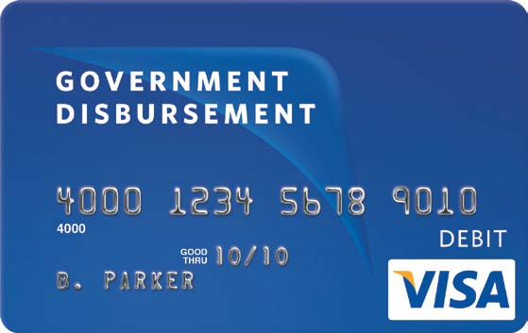
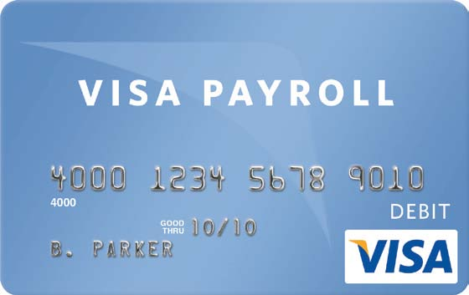
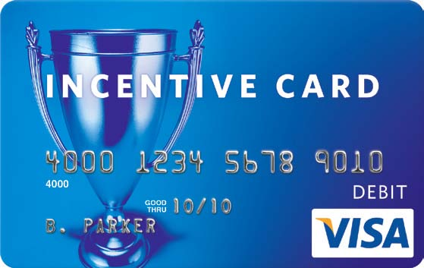
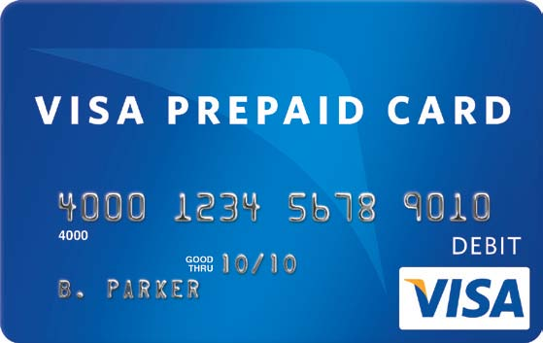
Attention Cardholder: If you are unable to get cash from your prepaid card at a bank branch that accepts Visa, or if you are charged a withdrawal fee in error, please call the toll free number on the back of your Visa prepaid card.

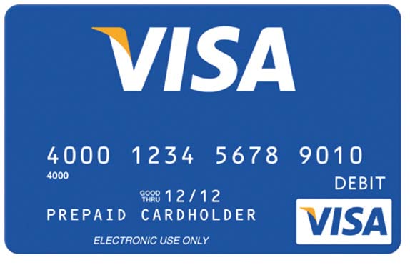
*Certain conditions may apply to cash disbursements in accordance with Visa U.S.A. Inc. Operating Regulations and Visa Prepaid Card program guidelines.

